Poseidon

User Manual

CIDCO

D.D. 2021-03-12

## Index

**Index** **3**

**System Requirements** **4**

**Connection Instructions (WiFi)** **5**

**Web Interface - (ROS core not launched) [Yellow card]** **6**

**Web Interface - (System not ready)[Red card]** **7**

**Web Interface - (System ready)[Green card]** **8**

**Web Interface - (Record)** **9**

**Web Interface - (System Status)** **10**

**Web Interface - (Download dataset)** **11**

**Web Interface - (Automatic IMU calibration)** **12**

**Web Interface - (Manual IMu and Sonar calibration)** **13**

**Connection block diagram** **14**

**Wiring Diagram** **15**

## System Requirements

Power : 12Vdc from a 12V battery or a 12V psu.

*Never apply power on the system if the GNSS antenna and/or the Sonar is not connected!*

## Connection Instructions (WiFi)

First step : Connect to the **Hydro B** wifi network. The password to connect is : cidco1234

Second step : Open a web browser and type 192.168.1.1

## Web Interface - (ROS core not launched) [Yellow card]

If ROS is not launched, the web page will look like this.

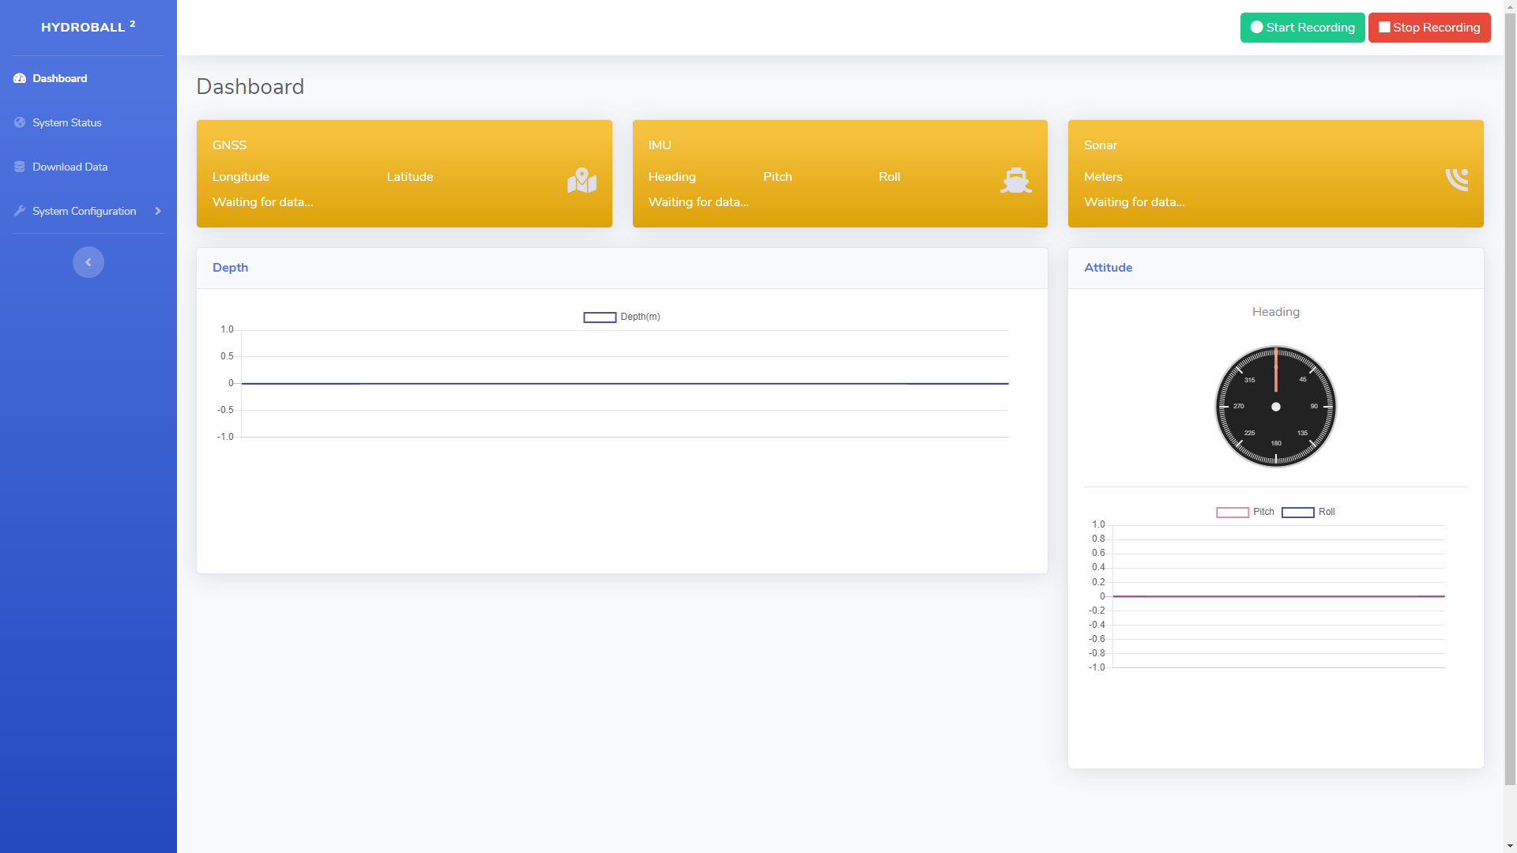

## Web Interface - (System not ready)[Red card]

If the system is not ready one of the three cards (NDSS, IMU, Sonar) will be red.

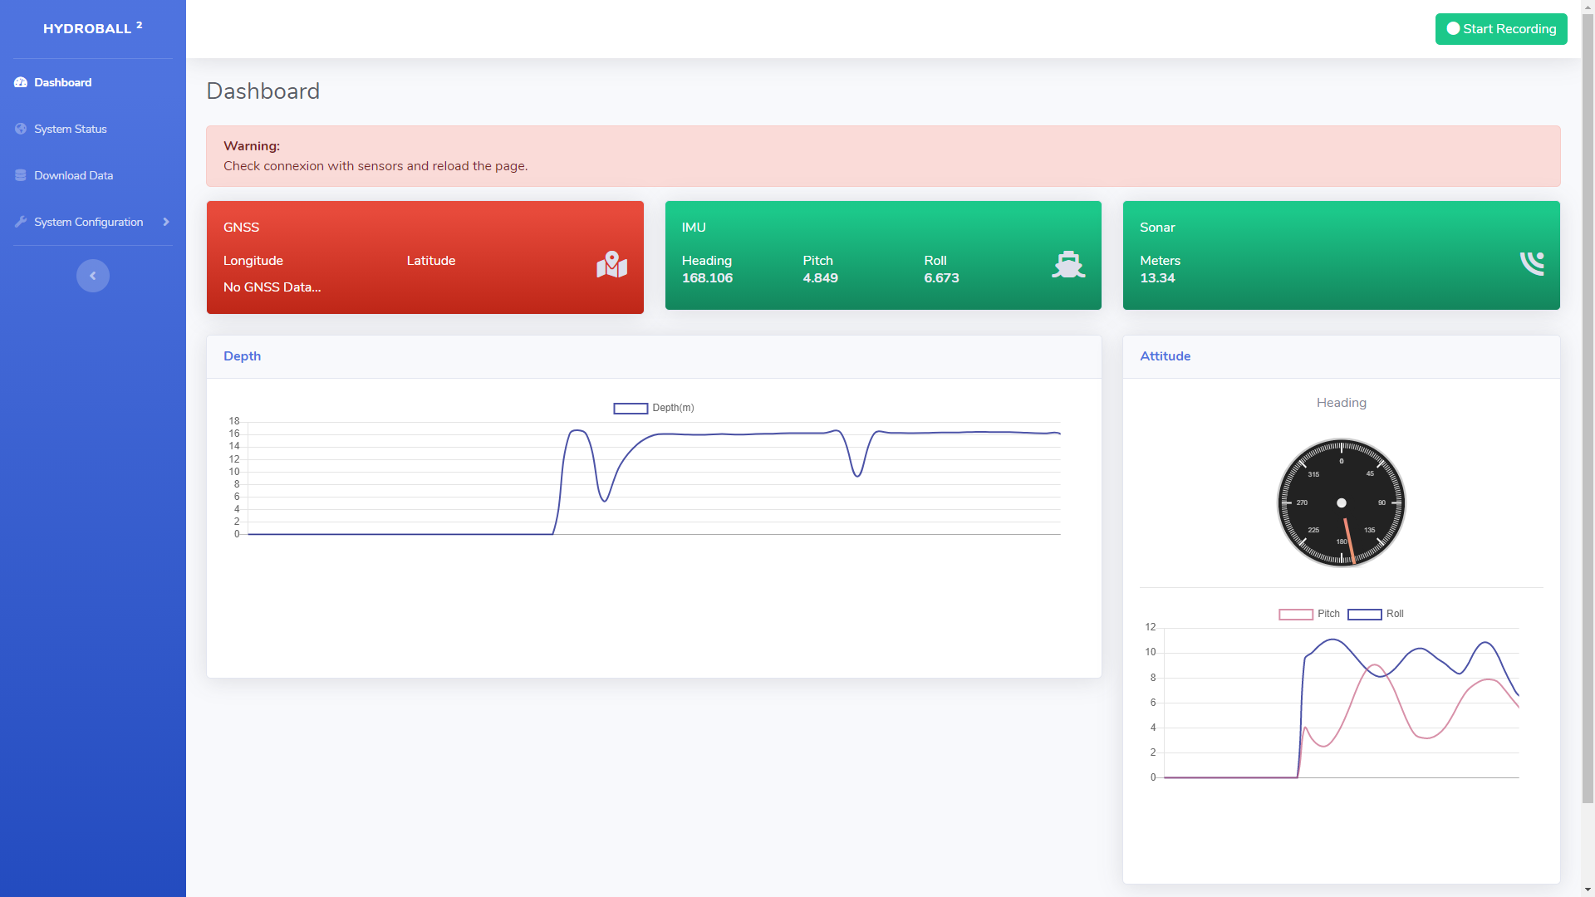

GNSS (red) - You have to wait a few minutes until the GNSS obtain the 3D fix. ...

IMU (red) - ...

Sonar (red) - ...

## Web Interface - (System ready)[Green card]

When the system is ready the three cards will be green.

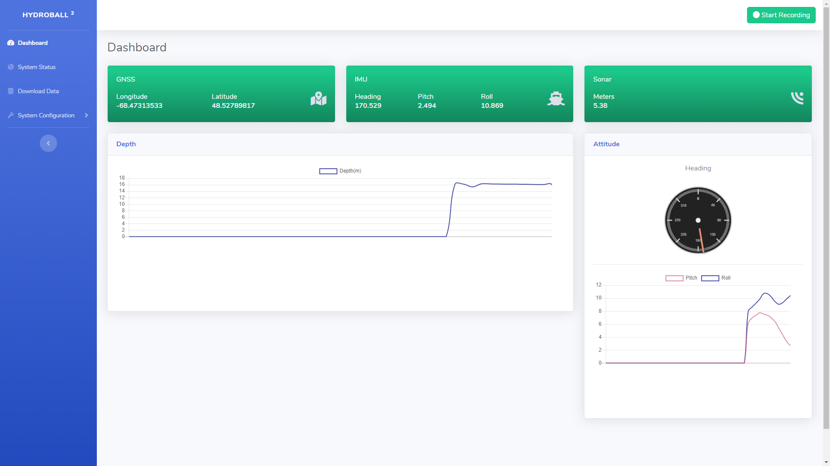

At this time you can start recording by pressing the green [Start Recording] button.

## Web Interface - (Record)

Data recording is in progress.

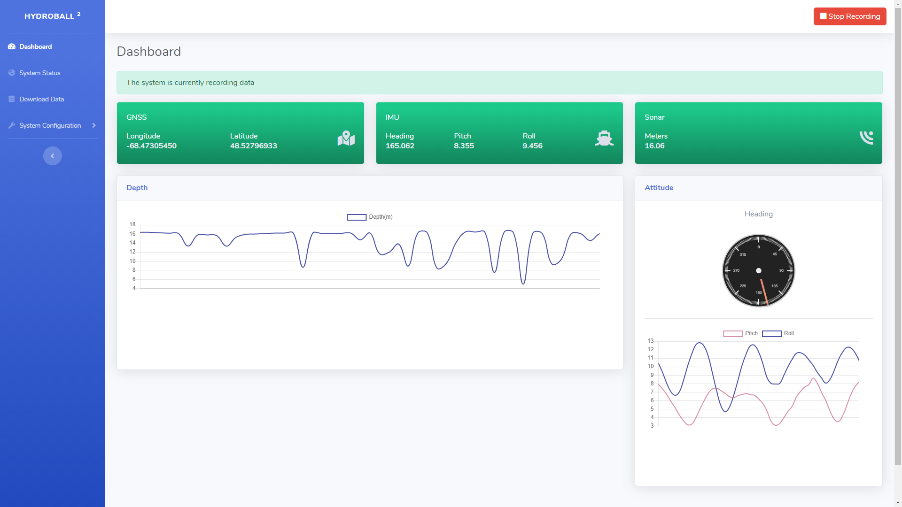

The system informs you that the recording is started in two ways.

The green button [Start Recording] toggle to red [Stop Recording]

A banner show [The system is currently recording data]

## Web Interface - (System Status)

You can see the system status on the System Status page.

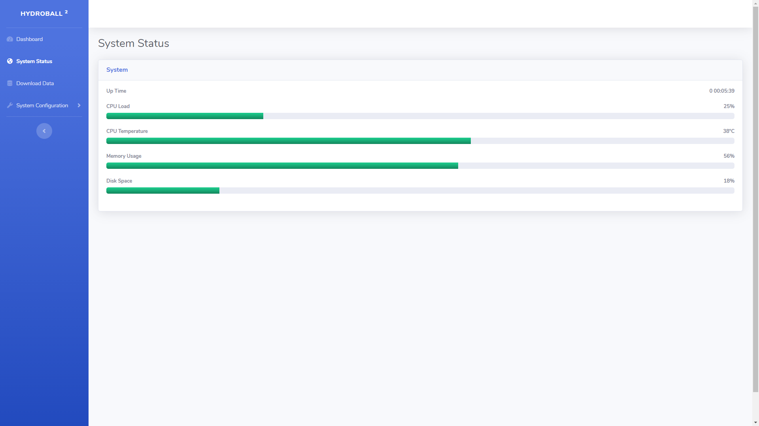

In this page you can monitor the state of the system.

CPU Load

CPU Temperature

Memory Utilization

Disk Space

## Web Interface - (Download dataset)

You can download the dataset from the Download Data page

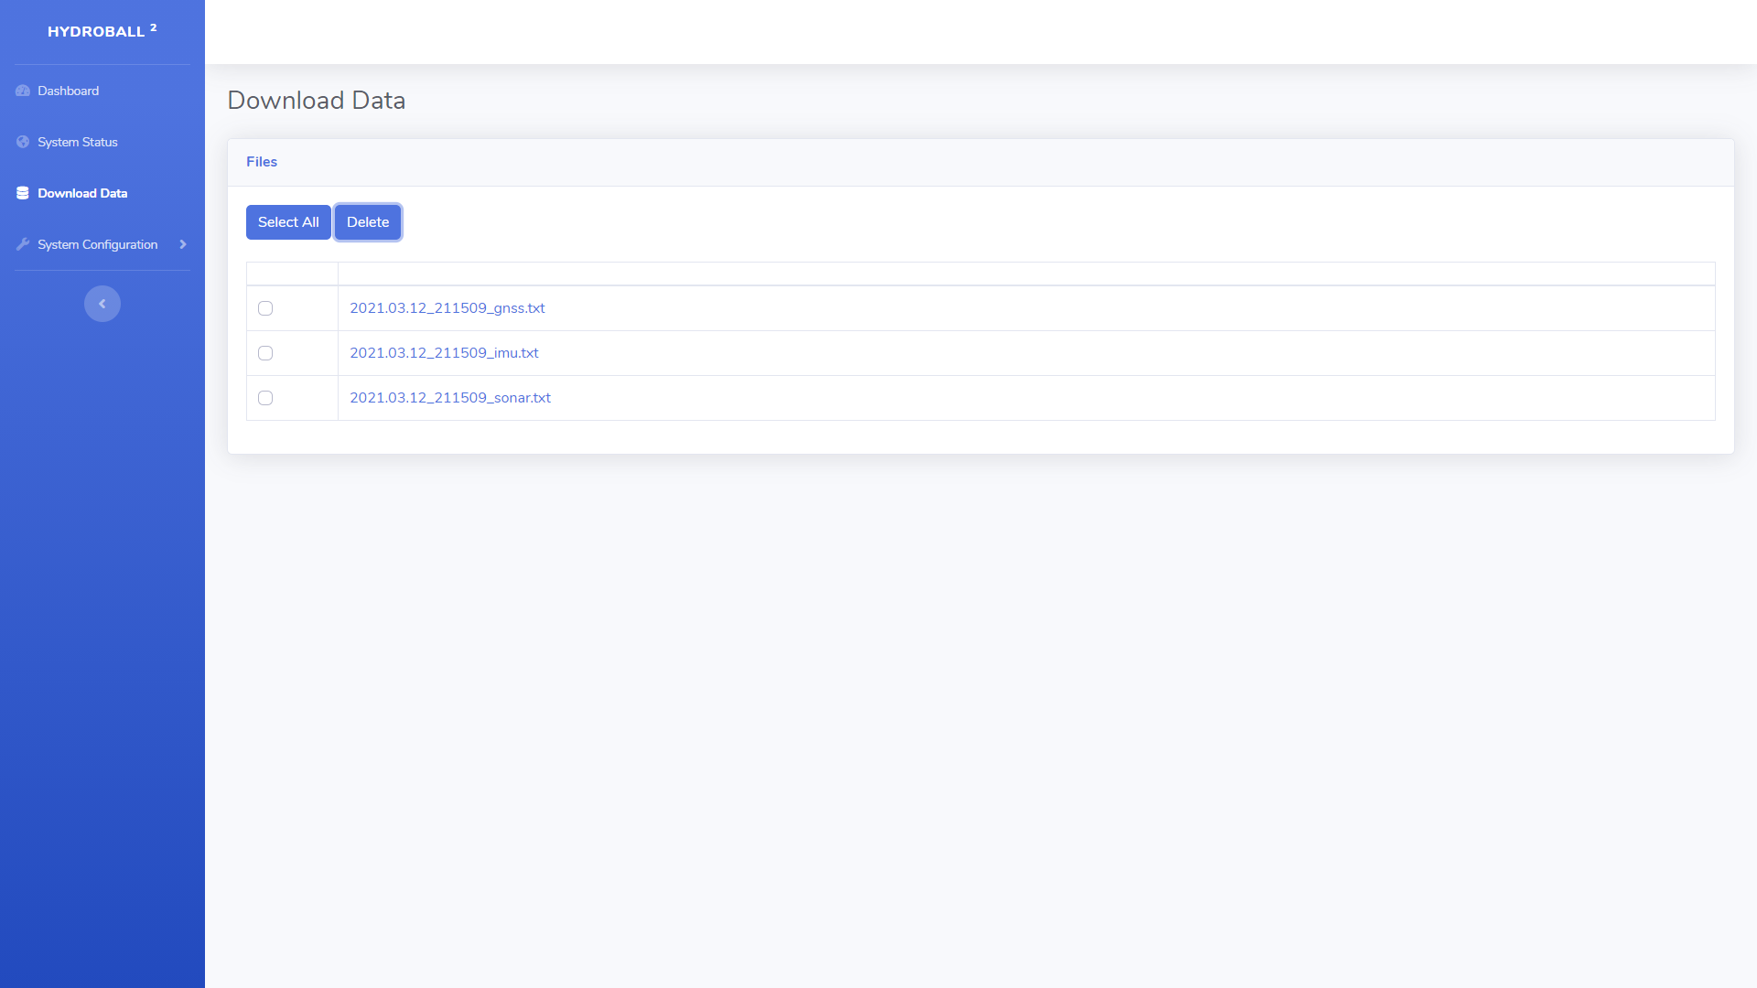

You can download each file by clicking on their name. You can select the deleted files with the checkboxes or use the [Select All] button. When you press the [Delete] button a modal window will prompt you to confirm the deletion of the selected files.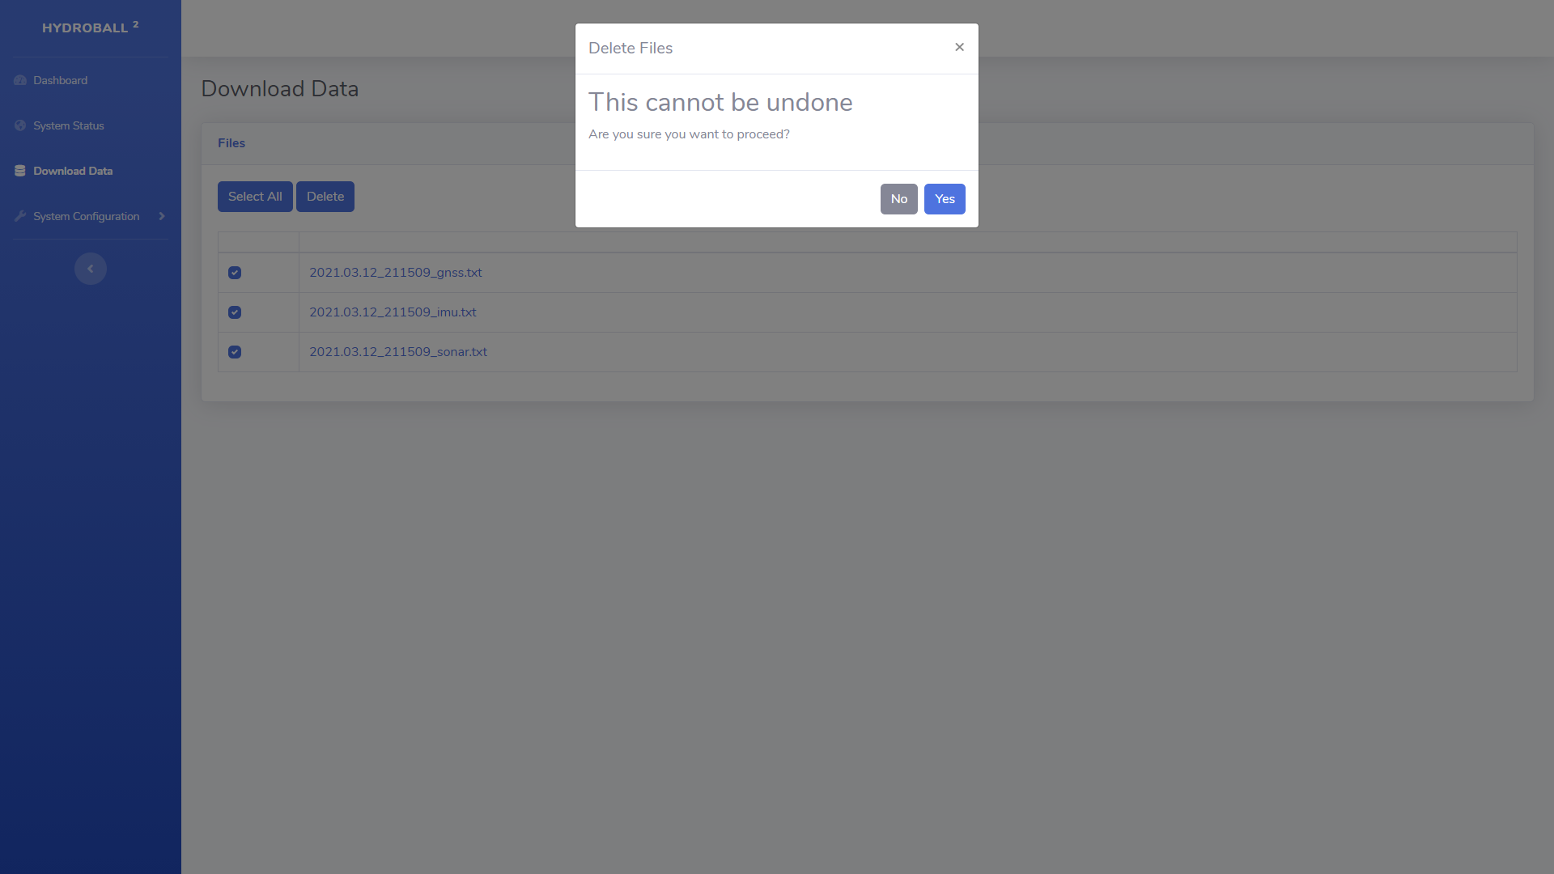

## Web Interface - (Automatic IMU calibration)

This page is used to launch the automatic calibration procedure of the IMU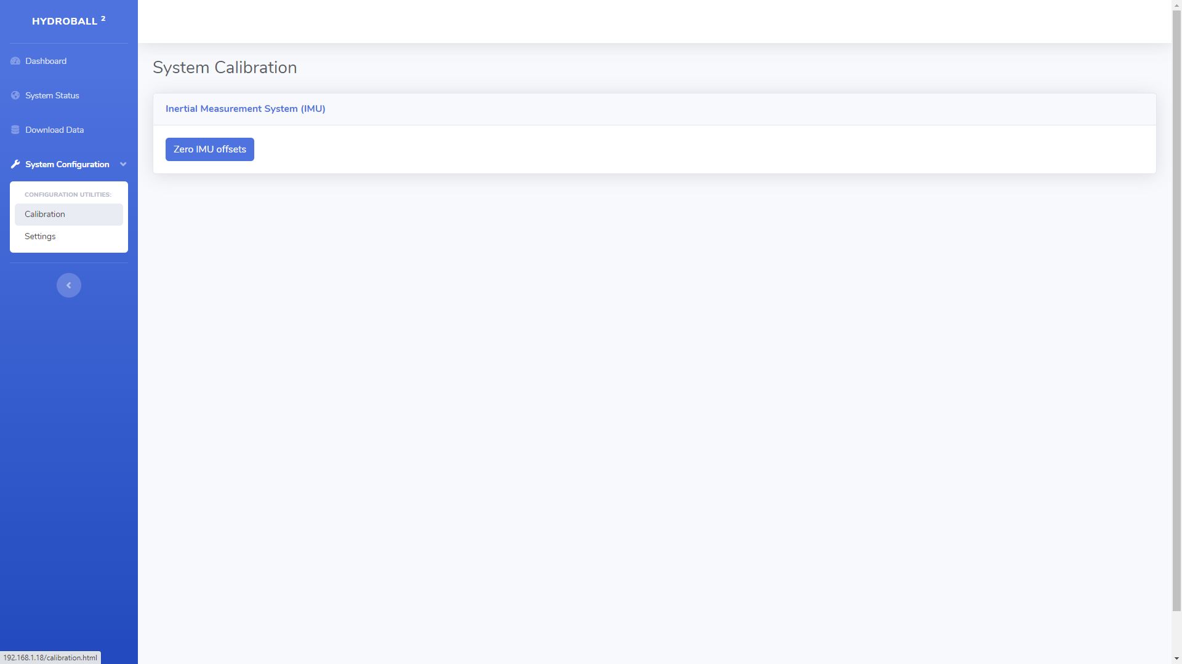

## Web Interface - (Manual IMu and Sonar calibration)

This page allows you to manually calibrate the IMU and Sonar.

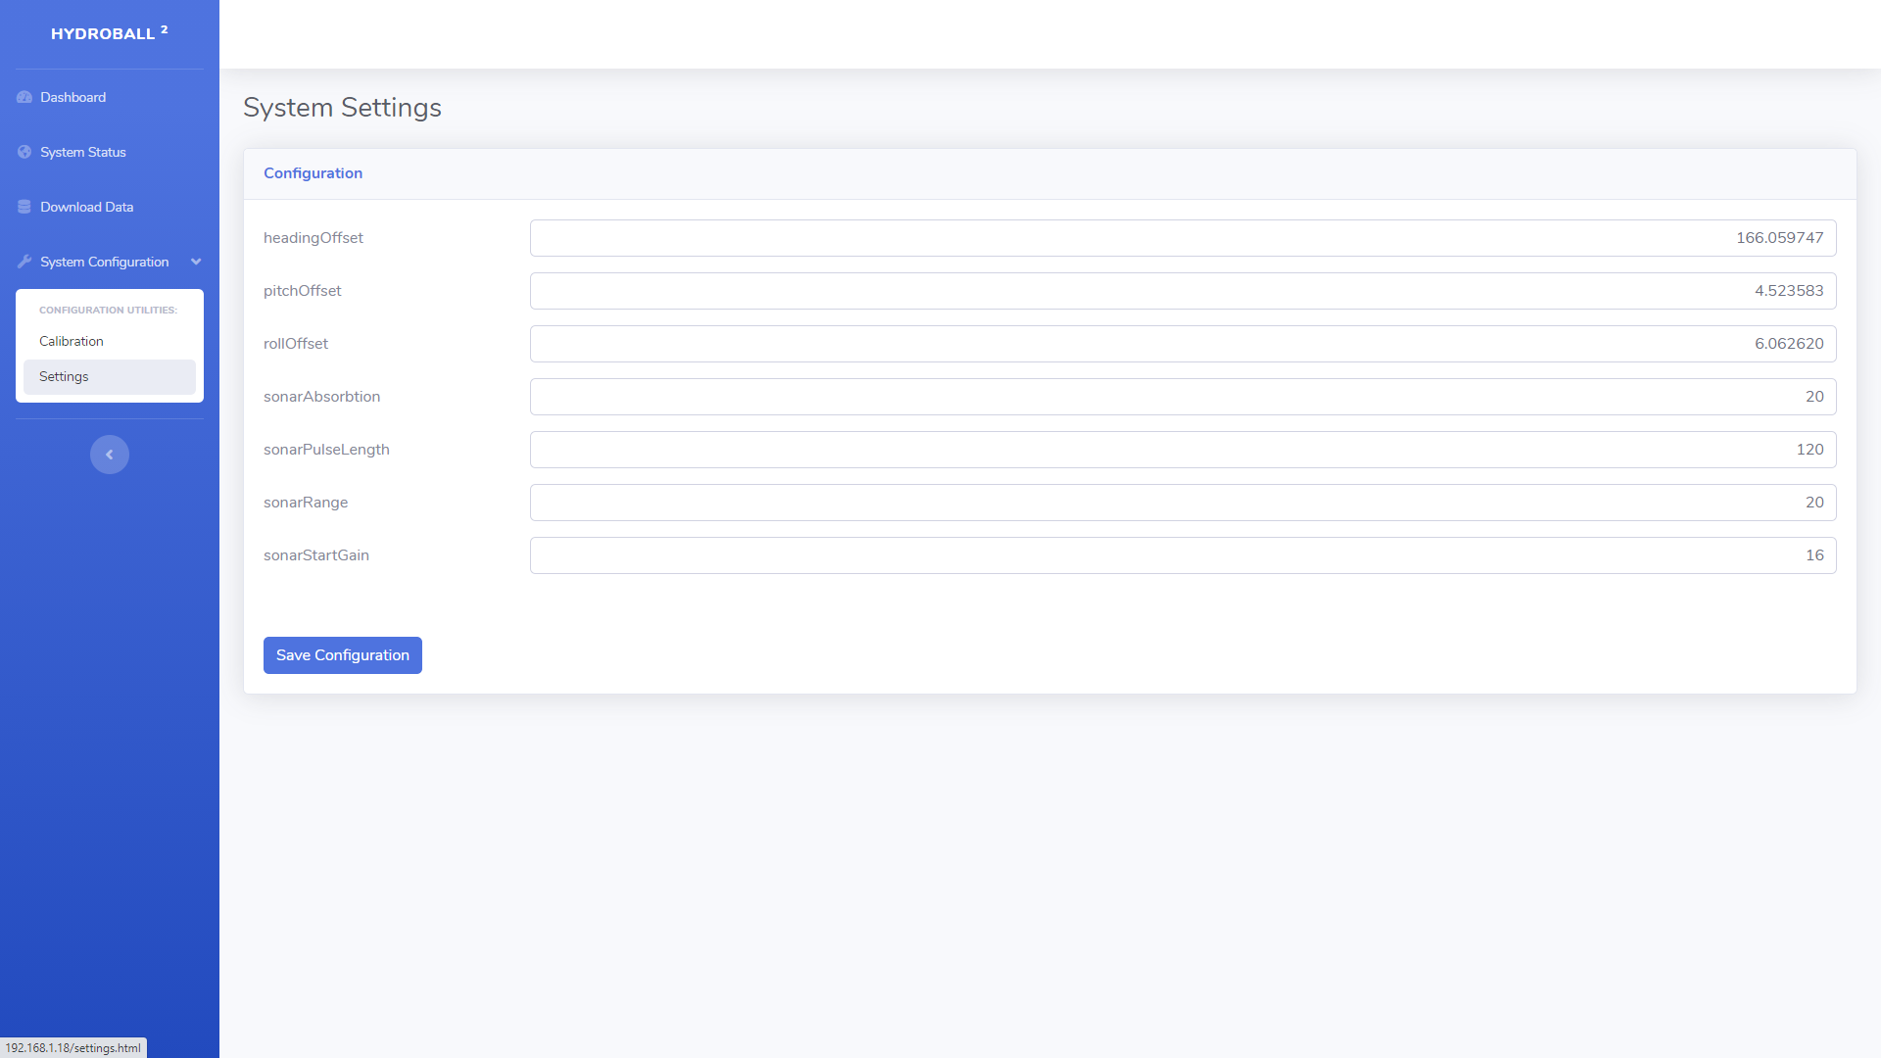

## Connection block diagram

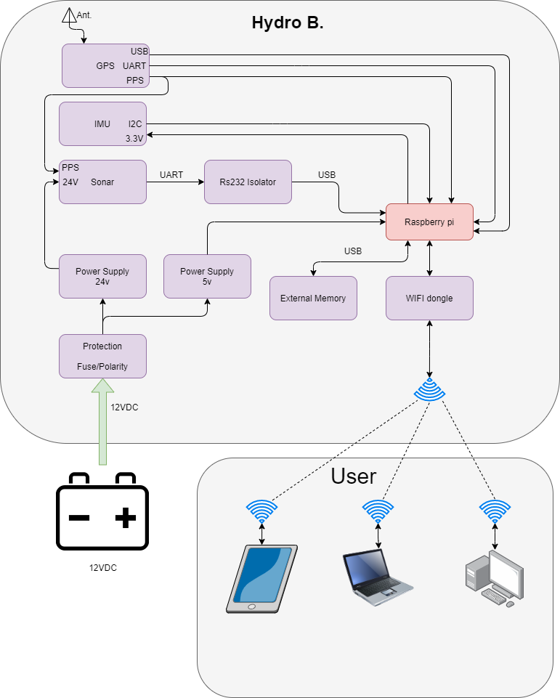

## Wiring Diagram

